EXPT NO 8 : Real-time monitoring of traffic in Youtube data streaming using Wireshark

Objectives
1. To capture YouTube streaming traffic using Wireshark and identify the data packets associated with video transmission.
2. To estimate the maximum bitrate of a YouTube video stream using the captured traffic statistics and analyze bandwidth utilization.
Software Requirements
- Wireshark
- Web Browser (Google Chrome/Mozilla Firefox)
- Internet Connection
- YouTube Website
Theory
Bitrate is the amount of data transmitted per unit time during video streaming and is typically measured in bits per second (bps), kilobits per second (kbps), or megabits per second (Mbps). A higher video resolution generally requires a higher bitrate and consumes more network bandwidth.
Procedure
Step 1: Open Wireshark and select the active network interface.
Step 2: Click Start Capturing Packets.
Step 3: Open a web browser and navigate to: https://www.youtube.com
Step 4: Select a YouTube video and set the video quality to 720p (or any specified resolution).
Step 5: Play the video continuously for approximately 60 seconds.
Step 6: Stop the packet capture after the streaming duration.
Step 7: Apply the filter: tcp or tls to isolate streaming traffic.
Step 8: Navigate to: Statistics → Conversations or Statistics → Endpoints and determine the total amount of data transferred during the streaming session.
Step 9 Record: Total Data Transferred (Bytes), Streaming Duration (Seconds)
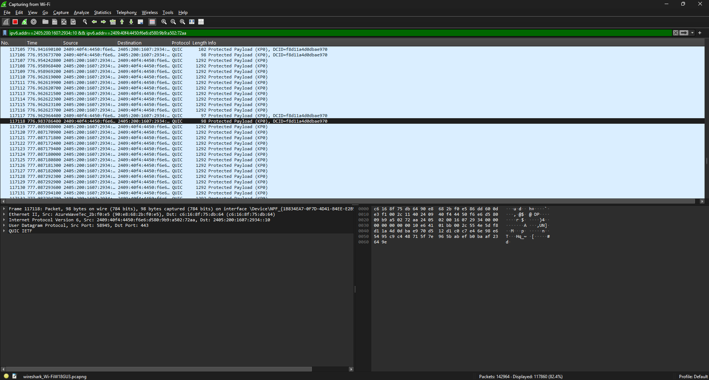

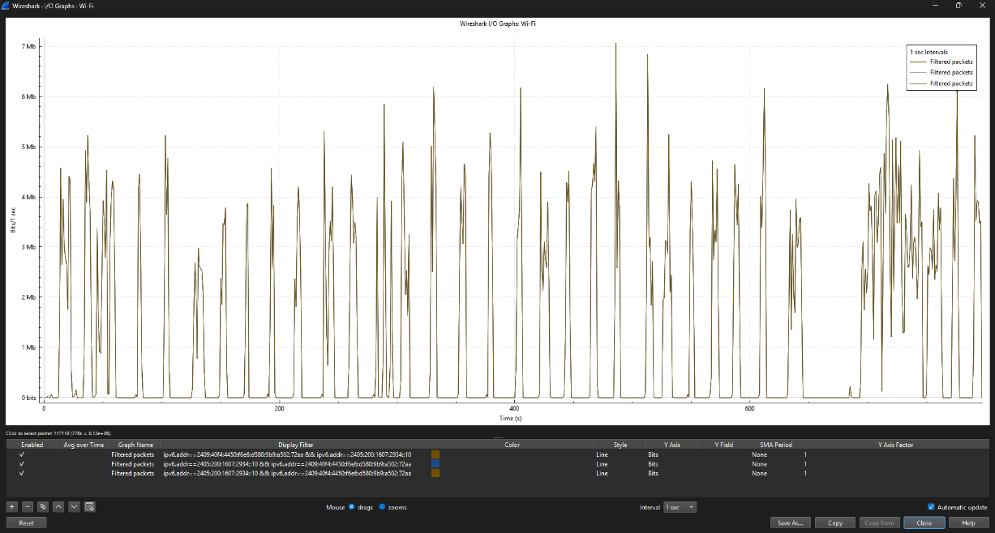
Step 10: Calculate the average bitrate using:
Resolution | Time frame | Maximum data rate (bits/sec) | Average data rate
1280 x 720 | 216 | 4.215 x 10⁶ | 4.540 x 10⁶
 | 238 | 5.306 x 10⁶
 | 245 | 4.199 x 10⁶
 | 261 | 4.441 x 10⁶
1920 x 1080 | 711 | 4.596 x 10⁶ | 5.316 x 10⁶
 | 718 | 5.611 x 10⁶
 | 744 | 4.928 x 10⁶
 | 776 | 6.13 x 10⁶

Result 1
The YouTube streaming traffic was successfully captured using Wireshark. The total amount of data transferred during the video playback session was identified from the captured packets, enabling analysis of the network resources utilized by the streaming application.
Result 2
The average bitrate of the YouTube video stream was successfully estimated using the captured traffic statistics and streaming duration. The results demonstrated the relationship between video quality, data transfer rate, and bandwidth consumption during video streaming.

